GETTING STARTED WITH THE WEST END SYNAGOGUE LIBRARY ONLINE CATALOG
Library Access
To access the online library catalog, go to the URL: https://www.libib.com/u/wes.

Getting a Password
You will need a password to use features of the online library catalog, including accessing your patron account page, and checking out an item.
- Click on “Patron Login”
- Click on “Need Password?” This will email you a password. Optionally, if your email is not in the library system you can request that the library manager set your password for you.
- If you need to reset your password, you can use the “Need Password?” link at any time or you can click “Patron Login” > select “edit profile” > and update your password.

West End Synagogue Libib Online Catalog Page
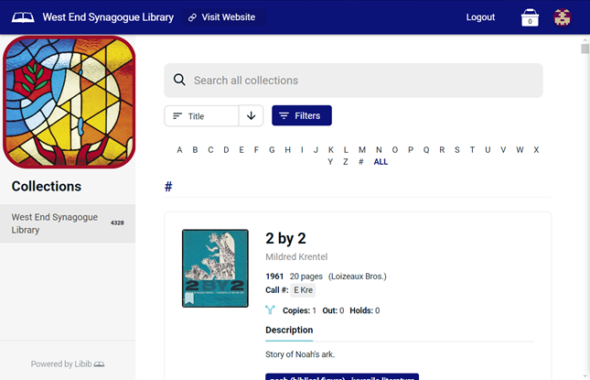

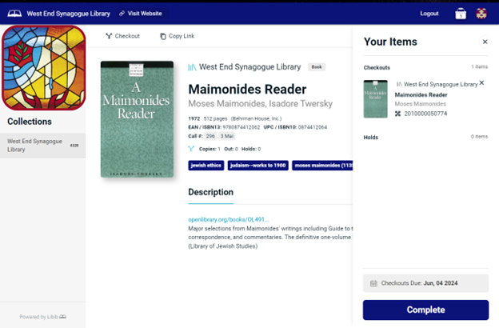
Checkout an Item
There are two ways to checkout items:
- Have the library manager checkout the item for you.
- Use quick self-checkout. There is a “Checkout” button at the top of the page that you simply click. If more than one copy of a book is available, you’ll be required to choose one of the provided barcodes from a popup list (Usually multi-volume set – not available currently). This will place the item in a “bucket” (located on top right of webpage) so that you can add additional books. Once you’ve added all your items click “Complete (Bottom right button of page).”


Update Patron Information
- Click on the Patron logo.
- Select “edit profile” from the options on the top right.
- This will allow you to update your patron information, change your password, and set your notification preferences.

See Active Items or Lending History
Click the Patron logo on the upper right of the webpage to access your active and past lending history.
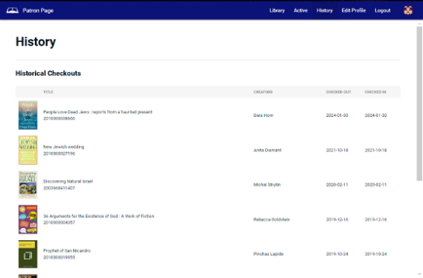

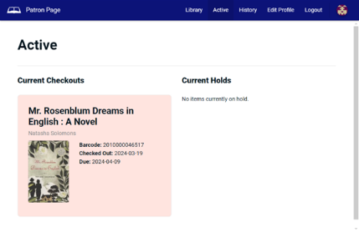
Active checked out items

Lending History

